Nuclear & Cell Division
 | 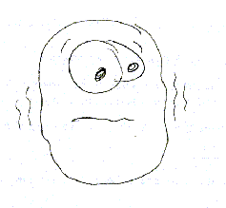 | 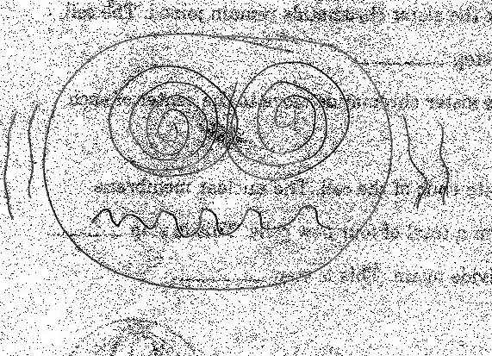
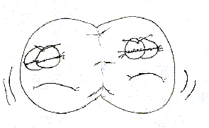 | 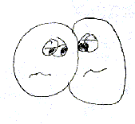 | 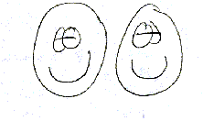

I. What will we be doing?

In this unit we will look at the ways in which cells reproduce to form more cells and why they do this. We will also take a peak at how special cells, known as sperm and egg cells, form. Understanding the ways that cells reproduce is essential to understanding genetics and heredity.

II. Objectives

Upon completion of this unit you will be able to:

- Define mitosis and give two reasons why it is important.
- Recognize the order of the phases of mitosis and the events that take place during each phase.
- Define and locate the following in a diagram of mitosis:

chromatid
chromosome
nuclear membrane
centromere
centrioles
spindle fibers

- Given diagrams or slide s of cells in various phases of mitosis, identify the phases they are in.

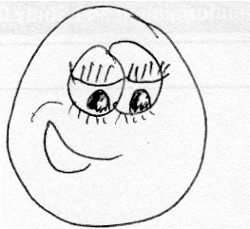
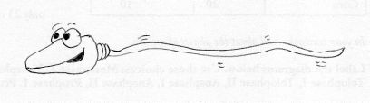Before you were, well, you, this is what you looked like:
How you doin’?

An egg cell from A sperm cell from
your mother. your father.

Now let’s take a closer look at the inside of the egg and the sperm to see what it is, exactly, your mother and father gave you.

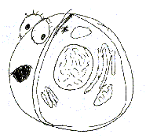
Can I get a little privacy here?

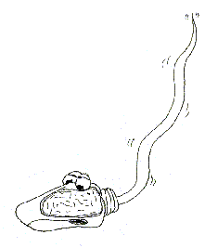
Don’t say I never gave you anything!

Now let’s put it together!

When you were fertilized, the egg from your mother and the sperm from your father joined together. The result was your first cell!

Contents of the Egg Cell | + | Contents of the Sperm Cell | = | Your First Cell

Inside your first cell you had everything necessary to become who you are today! Unfortunately, there was one small problem.
I’m sorry, but I don’t think we’ve met. I am you before you were you.

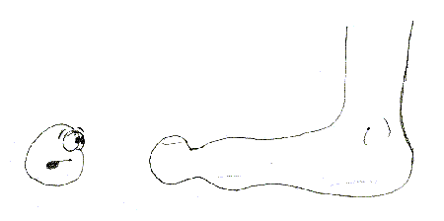
?

At your beginnings you were about the size of the period at the end of the sentence. How is it that you grew from that one little cell to your current size of about 10,000,000,000,000,000 (10 quadrillion) identical cells? In order for this to happen, your one cell had to have split into two cells…

which, of course, split into four cells, that eventually split into eight cells, etc.

That sounds easy, but the fact remains that each cell must be an identical copy of the last. In order to do this, your first cell had to make a copy of everything inside of itself so that when it split, each new cell would have the same of everything.
Fertilized eggman; making copies for the future. The Fertilator. The sperm and egg combo.

Hey, Phil.
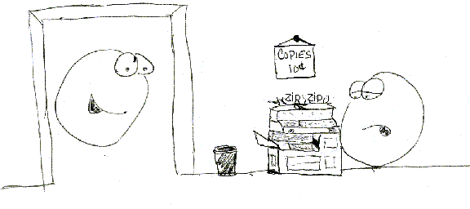

For most organelles the process of replication is so unimportant that you are not required to learn it. However, the replication of the nucleus is so important that the city, county, state, and country requires you to take quality time out of your busy schedule to learn how your nucleus divides. Before we get to that, let’s look at the nucleus so we can be reminded of what it does and also what it contains.

Inside the Nucleus:

What is the job of the nucleus?

What is inside of the nucleus that is so special?

_____________ makes up _______________ which make up _________________!

As a result, what are chromotids?

(Note: Chromotid 1 is hardly 10 μm (.001cm) long but it contains 7cm of DNA!)
Draw a picture of a chromosome and label the chromatids, centromere, and chromosome. (page 98)

When you were fertilized you received 23 chromosomes from your father and 23 chromosomes from your mother. With that knowledge let’s try some math problems.

MATH PROBLEMS:
An egg with twenty-three chromosomes left the ovary at noon on Thursday and was traveling down the Fallopian Tube at 2 cm per hour. One hour later a sperm with twenty-three chromosomes traveling at 3 cm per hour fertilized the egg. After fertilization how many chromosomes did the fertilized egg have?

If a sperm with twenty-three chromosomes traveled 23 cm in Denmark during a rainstorm on Tuesday to fertilize an egg with twenty-three chromosomes at 98 degrees, how many chromosomes will the fertilized egg have?

If a fertilized egg ends up with forty-six chromosomes and it must get half from its father and half from its mother, how many chromosomes did each parent give the fertilized egg?

Write your own chromosome story problem in the space provided:

Now that you get the idea that you have 46 chromosomes in each of your 10,000,000,000,000,000 cells (actually there is one exception to this rule) we need to learn how your first cell, and those after, copied and delivered these chromosomes. In order for us to accomplish this task we need help from the cell cycle.

The cell cycle is the “life” of a cell. It is the chain of events that happens to a cell over and over and over and over and over again until the cell dies, hence the name cell cycle. Take a few minutes and copy the information in the pie chart on page 97 into this circle.

~INTERPHASE~
Looking at the chart, which stage (interphase, mitosis, or cytokinesis) does the cell remain in the longest?

Which is the shortest?

Which individual activity (organelle duplication, growth, DNA copying, mitosis, or cytoplasm division (cytokinesis)) does the cell spend the most time doing?

In our discussion of the cell cycle, let’s begin with what your first cell began with, interphase. In interphase three major things must happen in order for your cell to survive.

- Growth: What two important things happen in this activity? (page 97)

- DNA Replication: Why is it important for the cell to replicate its DNA? (page 97)

~MITOSIS~ (My toe, sis!)
Once the cell has prepared for division, it is not yet ready to divide. Before the cell can divide it must make sure that there is a nucleus for each new cell. Also, the cell must make sure that each new cell receives the 46 chromosomes (23 from mom and 23 from dad) that it deserves. The process of dividing the nucleus is called mitosis.

What happens during mitosis? (page 98)

In order to understand this confusing process better, mitosis is divided into four phases (PMAT), although it is just one continuous process, that contain big scientific words.

The first phase in mitosis is referred to as ____________________. (The prefix pro means before)

The major events of prophase:

Draw a picture of a cell in prophase. Label the chromatid, centromere, centriole, nuclear membrane, and spindle fibers.

The second phase of mitosis is called ____________________. (The prefix meta means between. I remember “m” is for middle.)

The major events in metaphase:

Draw a picture of a cell in metaphase. Label the chromatid, centromere, centriole, and spindle fibers.

The third phase of mitosis is referred to as __________________. (The prefix ana means upward or backward.)

The major event of anaphase:

Draw a picture of a cell in anaphase. Label the chromosomes, centromere, centriole, and spindle fibers.

The final phase of mitosis is referred to as ___________________. (The prefix telo means end. I just remember it looks like a telephone.)

The major events in telophase:

Draw a picture of a cell in telophase. Label the chromosomes, centromere, centriole, nuclear membrane, and spindle fibers.

During telophase the cytoplasm also divides in a process called ___________________.

As you can see, you have now created two separate nuclei, each with the same amount of chromosomes and each with the same identical chromosomes. Take some time to practice the phases of mitosis in these creative ways.
(* denotes projects to do by yourself, ** denotes projects for groups of two, and *** denotes projects for groups of three or four)

- *Using note cards, create a flipbook animation of the cell cycle. Include growth 1, synthesis, growth 2, mitosis, and cytokinesis. Be sure to use color.

- **Write a children’s story that takes us through the adventure of mitosis through a creative point of view. Become a chromatid or a spindle fiber or even the cell itself. Be creative and make sure you cover every phase of mitosis and the importance of each. Don’t forget to draw beautiful pictures! You will read these for the whole class to hear.

- ***Create a skit that demonstrates the phases of mitosis and the important events that occur in each phase. Once finished you will perform in front of the class.

