Hobart, Munster prevail
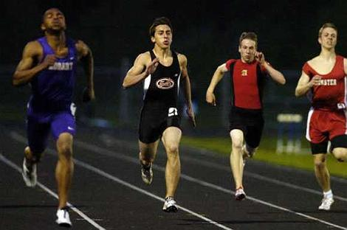
Lowell's Cole Midgett, Andrean's Christian Hood and Munster's Bart Grabowski chase Hobart's Kendall Gunn to the finish of the 200-meter dash.
(Jeffrey D. Nicholls/Post-Tribune)
May 12, 2010 BY RYAN HASKELL, POST-TRIBUNE CORRESPONDENT
HIGHLAND -- Jarvis McMillian didn't have a chance to win a conference championship when he ran for Wirt last season.
So when the Gary high school closed last summer, he knew he wanted to make an immediate impact for his new coach and teammates at Hobart.
He hasn't looked back since.
McMillian won three events in Tuesday's Northwest Crossroad Conference championship meet to lead the Brickies to their first conference crown in four years as Hobart edged defending NCC champ Lowell, 133.5 to 117.5. Andrean, which won the Calumet Invitational last week, finished third with 102 points, followed by Munster (84.5), Highland (71.5), Kankakee Valley (64.5) and Griffith (33.5).
In girls action, Munster won its third straight conference title with 169 points. Lowell was second with 114 points, followed by Highland (79), Andrean (71), Griffith (71), Kankakee Valley (59) and Hobart (55).
McMillian, who reached the state meet last season as a Troopers runner, broke the conference record with his first-place performances in the 100-meter (10.76 seconds) and 200-meter (21.89) dashes, while winning the 400-meter run in 49.22.
"This is my first time so it feels real good," the junior said. "With me being brand new to the school, I feel like I made a big difference in a lot of stuff and I'm glad we came together and did what we had to do to win."
Hobart coach Nick Byrd has loved his first year with the state-qualifying McMillian.
"I'd hate to be in his shoes," said Byrd, who has put a lot of stock in his sprinter. "When you look at him and you say, 'We expect first place in the 100, 200, 400 and 4-by-100 and you can't falter.'
"He's answered the bell and answered that pressure and he's a tremendous young man and a pleasure to coach. He brings a nice attitude to the team and makes me laugh a lot of times."
The Brickies hit a speed bump in the meet's seventh event when they lost the baton in the 4x100 relay but they kept their composure and went on with the conference title.
"They each knew what they had to do to help the school win," Byrd said. "We had a lot of our seniors step up like Paul Goodman, who did a tremendous job in the 2-mile. We had a little hiccup in the 4x1 where we lost the baton. All of our kids looked at us and said 'We lost those points but we're not going to let this stop us.' It was a total team effort tonight."
Goodman finished fifth in the 3,200 run (10:14.13) to contribute, while Thomas Camacho finished third in the 110-meter hurdles (15.45) and fourth in the 300-meter high hurdles (42.56). In the field events, Ryan McGuire won the pole vault (12-6), Jeremy Koselke won the discus (134-10) and finished third in the shot put (46-3) and Matt Stewart was second in the high jump (6-1).

