Hobart's McMillian dominates boys track sectionals
BY MATT DOUTHETT - Times Correspondent | Posted: Friday, May 21, 2010 12:00 am
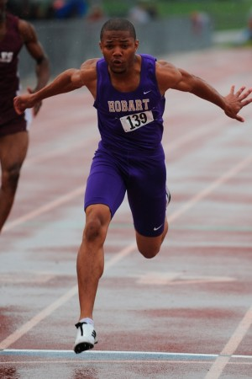
CROWN POINT | If everything goes as planned, Hobart will go on to capture its first boys track sectional title since 1958.
Mother Nature just wanted the suspense to continue for an extra day.
Steady rainfall caused officials to postpone the pole vault to today at 4:30 p.m. After 15 events were scored, Hobart holds a 106-89.5 lead over second-place Merrillville. Though the Pirates have the first seed (Byron Ferrell) and third seed (Monte Brown), Hobart's Ryan McGuire and Kyle Reid are seeded second and fifth, respectively, meaning Merrillville likely will finish second.
No matter what happens today, the Brickies wouldn't be in this position without star sprinter Jarvis McMillian.
McMillian continued his usual domination of the sprint events, capturing titles in the 100 meters (10.87), 200 (22.57) and 400 (48.36). While McMillian expected to win those events, he was happiest with the 1,600 relay, where he ran the anchor leg to help Hobart finish second (3:25.22) behind Lowell (3:22.73).
"I thought I had to go out there and prove (something) to everybody who has been talking down about my team," he said. "(But) those are things you expect at a track meet, with everybody talking about 'I'm going to beat you.'"
Hobart coach Nick Byrd recognized McMillian as "icing on the cake" to his already solid core of runners.
"He's done a great job, and he means a lot to our program," Byrd said. "But more importantly, he's a great kid. The kids do their best to not let him down, but more importantly, not let the team down.
"I'm proud of every single one of them today."

